Products Repository Implementation Exercise
This exercise will demonstrate the full implementation of products repository class.

ProductsRepository Class Implementation
Navigate to SixtyThreeBits.Core → Infrastructure → Repositories and new Products directory. Then create two items within the Products directory:
- A DTO subdirectory for data transfer objects
- A ProductsRepository.cs file for the repository class

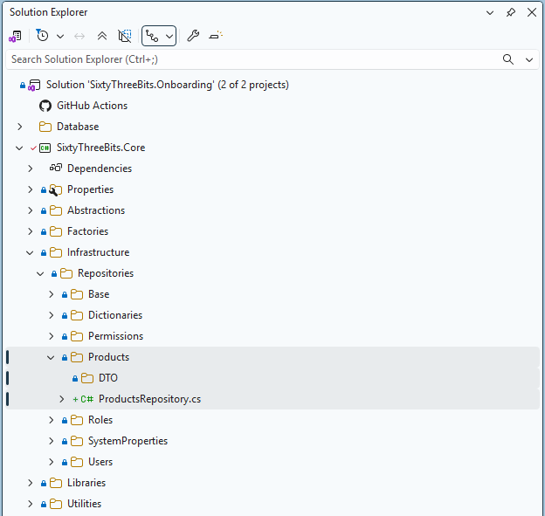

Open the ProductsRepository.cs file and configure the class according to the screenshot below.
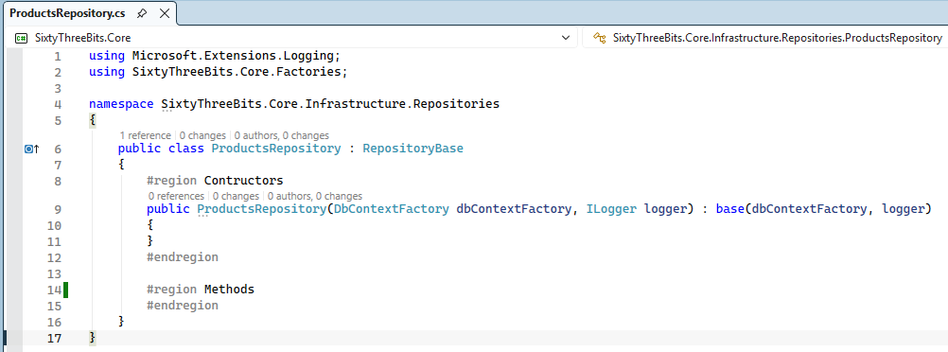

ProductsIUD Method Implementation

Navigate to the DTO subdirectory and create new file ProductsIudDTO.cs and implement it according to screenshot below.
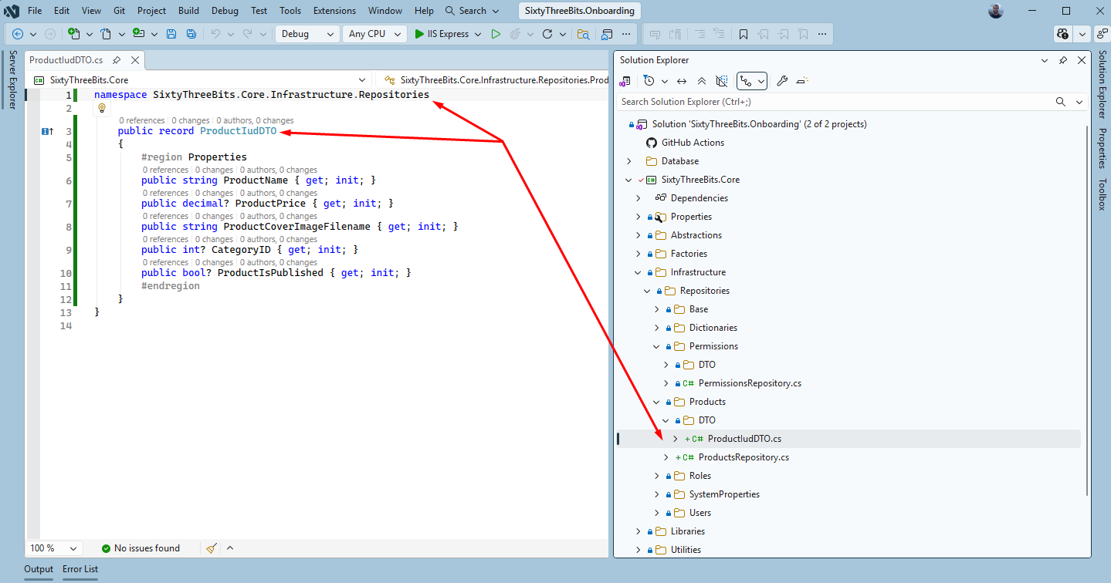

Below is the demonstration of how ProductsIUD stored procedure’s @productJson values are matching up to ProductIudDTO properties.
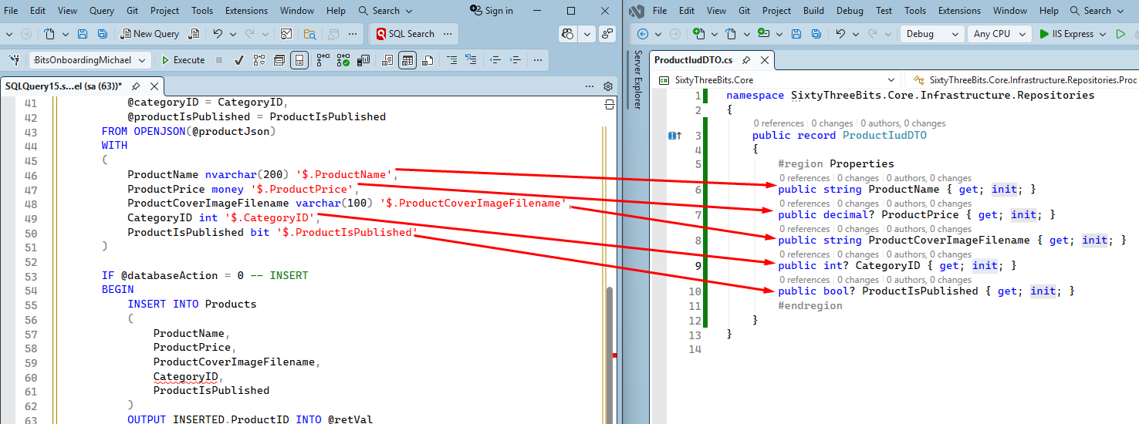

Go back to the ProductsRepository.cs file and implement ProductsIUD method according to screenshot below.
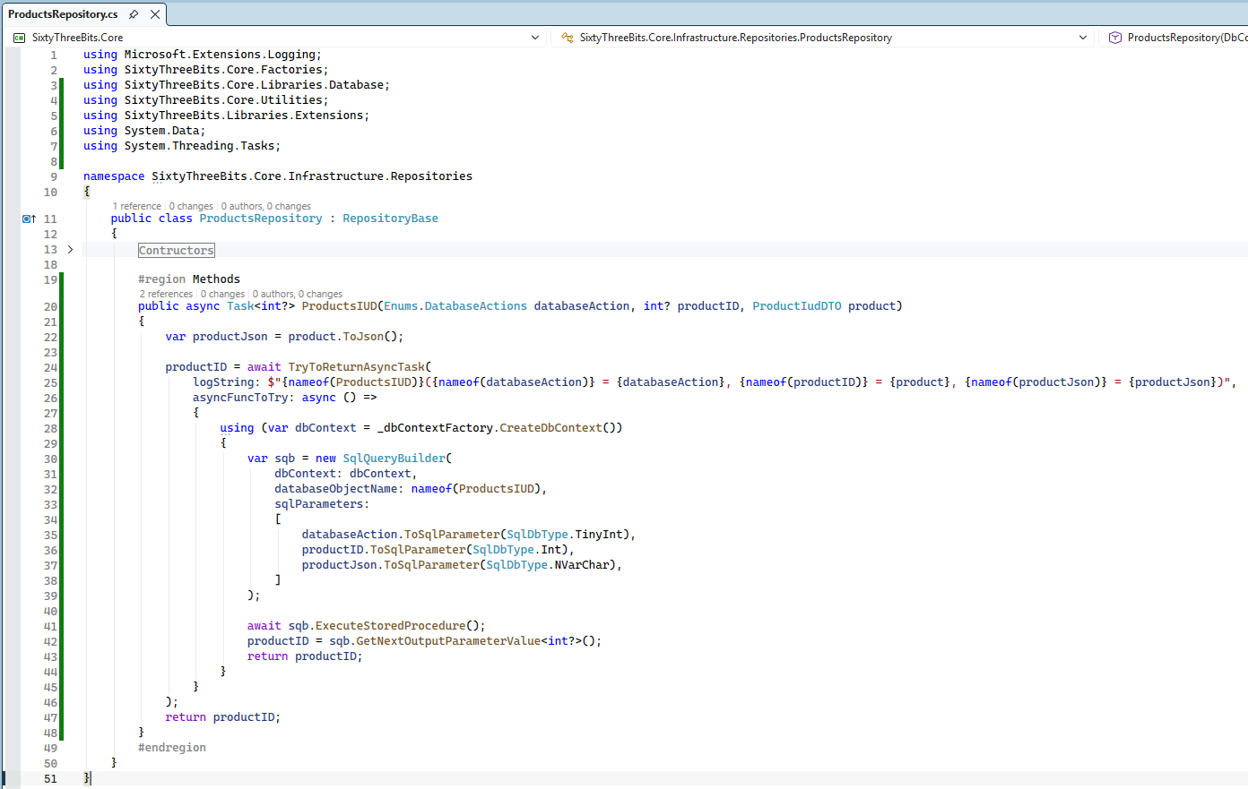

ProductsList Method Implementation
Navigate to the DTO subdirectory and create new file ProductsListDTO.cs and implement it according to screenshot below.
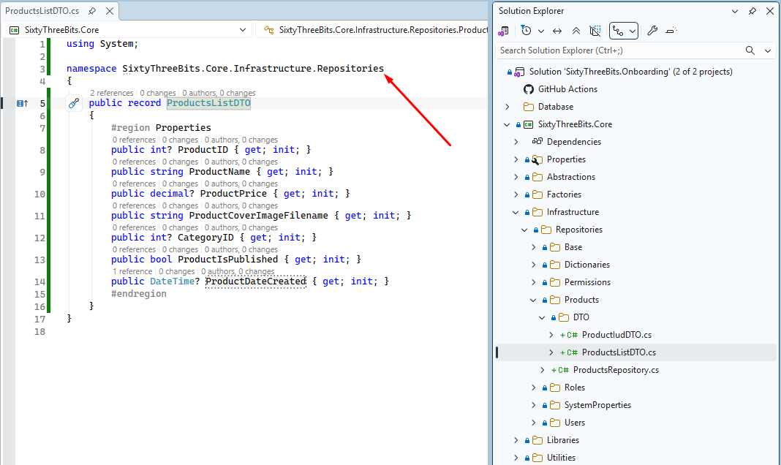

Below is the demonstration of how ProductsList SQL Function columns are matching up with ProductsListDTO properties.
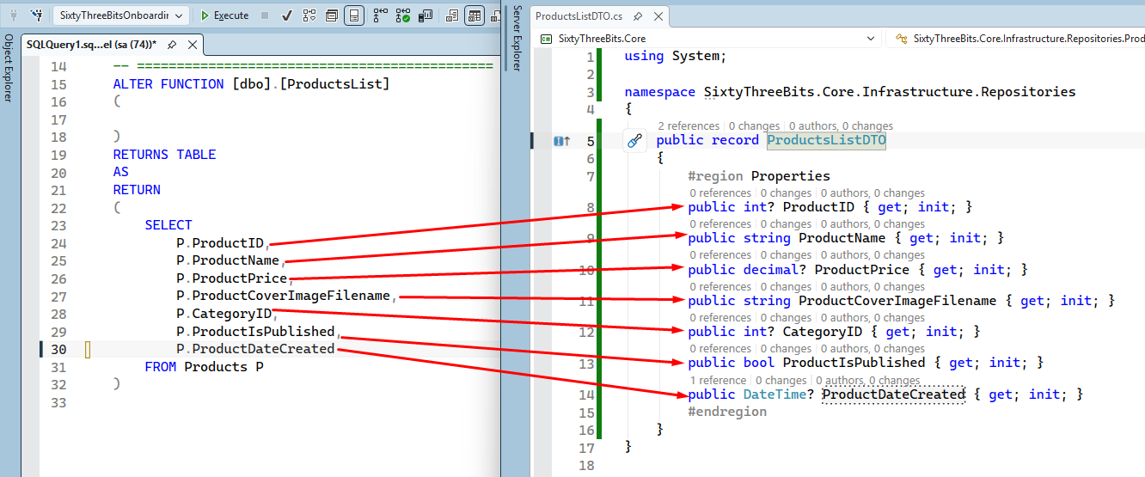
Go back to the ProductsRepository.cs file and implement ProductsList method according to screenshot below.
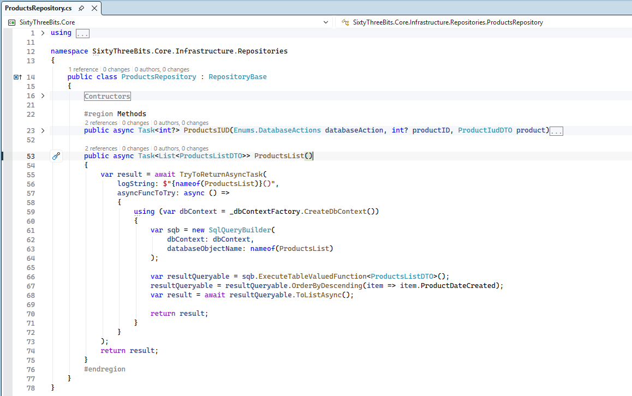

ProductsGetSingleByID Method Implementation
Navigate to the DTO subdirectory and create new file ProductDTO.cs and implement it according to screenshot below.
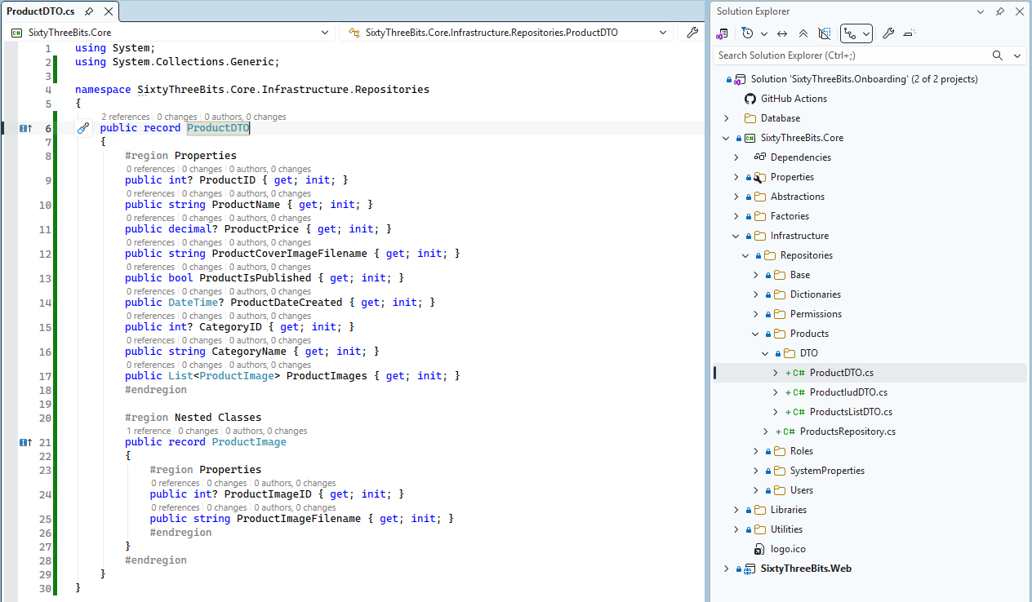

Go back to the ProductsRepository.cs file and implement ProductsGetSingleByID method according to screenshot below.
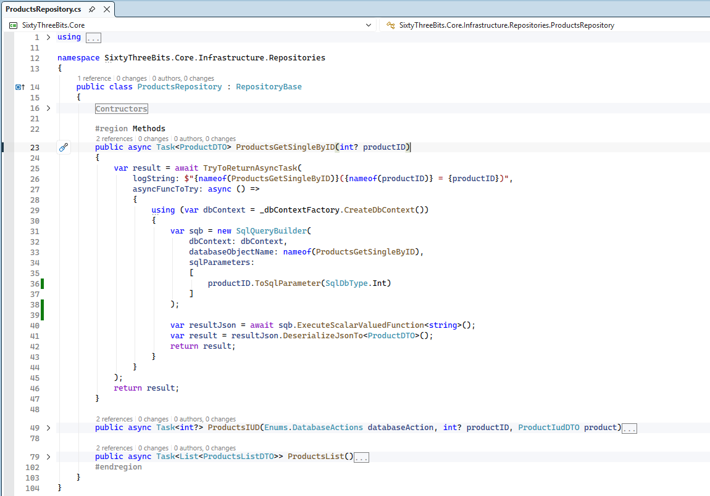

Registering the Repository in the Factory
Navigate to SixtyThreeBits.Core → Factories and open RepositoryFactory.cs. Add method according to the screenshot below.
